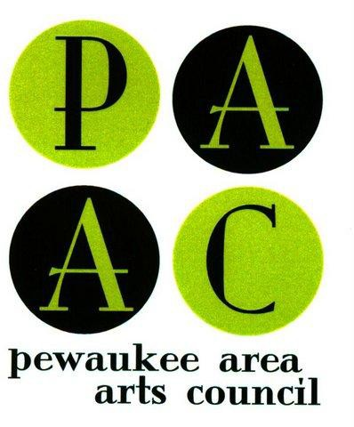
The Pewaukee Area Arts Council

Lake Country Photo Contest

For Amateur Photographers

Deadline Monday, June 7, 2021 at midnight
Submit one or two digital images to Pewaukeearts@gmail.com

This photo contest began with Lake Country’s Clean Water Festival whose mission was to raise awareness for the increasing need for the preservation of Lake Country’s lakes and to raise money for funding efforts to clean the lakes so that everyone may continue to enjoy the fun and the beauty that the lakes bring to our community.

The PAAC Lake Country Photo Contest is a visual representation of that event’s mission, by highlighting the beauty, enjoyment and importance that Waukesha County lakes and waterways bring to our community. Photos from Waukesha County are accepted according to the guidelines. Judging criteria and guidelines below are online at PewaukeeArts.org.

Prizes
Cash prizes will be awarded to 4 winners: 1st Place $200, 2nd Place $150, 3rd Place $100, and 4th Place $75. In addition, 3 winners will receive Honorable Mention ribbons. All winning entries will be featured online on the PAAC website, and possibly on display at the Lake Country Clean Water Festival on Pewaukee Beach or at a Pewaukee lakefront business. We encourage all amateurs to enter.

Photo Guidelines
-All entries must be taken between June 15, 2020 and June 7, 2021, or will be disqualified.
-All submissions must be original images taken of the natural lakes, rivers, streams, ponds and waterways in Waukesha County.
-Submit one or two digital images by email by Monday, June 7, 2021 at midnight.
-Entries should represent the natural beauty to be found at these locations and/or represent the importance and enjoyment these lakes and waterways bring to our Lake Country community.
-Photographs should not be digitally altered (beyond basic color balance or sharpness).
-Any image that can be identified as obscene, provocative or otherwise containing objectionable content will not be considered.
-Obvious advertisements for third-party entities are not allowed. (Advertisements are owned or licensed by their respective third-party entities and are subject to protections.)

Rules
-The contest is open only to amateur and hobby photographers.
-Each entrant in this contest is responsible for ensuring that he or she owns the images (took the photograph) or has the right to submit the photos by the owner.

Submission Guidelines
-You may submit one or two (2) digital entries (see Digital File Specifications below).
-You must complete the copyright release/application form below.

Submission Directions
-Your submission should include one or two digital photo entries PLUS a completed and signed version of the copyright release /application form (below). Everything must be submitted digitally by email to pewaukeearts@gmail.com. Please specify: Photo Contest in the subject line.
-The copyright release/application form will be accepted in either jpg or pdf format. (Tip: Print out the form and complete it before converting it into a digital file. If you do not have access to a scanner, you may take a photo of the completed form with your phone, and send that digital file with your entries.)

Digital Image File Specifications:
- Photos must be cropped to 8X10 proportions
- Photos must be submitted in jpeg format
- Photo file size large enough to result in a crisp 8X10 print and no larger than 2MB
- Each photo must be labeled with submitter’s first and last initial and the photo’s title (for example: JS Sunny Day on Lake) (JS = John Smith who is the photographer)

-Images taken before June 15, 2020 will be disqualified.
-Images re-submitted from previous years’ contests will be disqualified.
-Entries may be watermarked, but the watermark should be inconspicuous enough to not interfere with the judging of the photograph.
-Deadline for submissions is June 7, 2021 at midnight
-Winners will be notified by June 25, 2021
-Prize monies and ribbons will be mailed to the winners after June 29. (No printed photos will be mailed.)
-Entry in the contest gives PAAC explicit permission to display photographs locally and online, with proper attribution.

Judging - Criteria
-Images will be judged on the natural beauty of water, originality, technical excellence, composition, overall impact, visual appeal and artistic merit using the Judging Form. The judges appointed by PAAC shall determine winner eligibility at their sole and absolute discretion. All decisions by the judges are final.

Entrant Rights
-Entrant will retain all rights to any photography submitted.
-If your photograph is honored by the competition, you grant PAAC the right to display a printed image, and a digital version of the image online.
-As conditions of this permission, PAAC shall credit all photographs with the photographer’s full name. Questions: email to pewaukeearts@gmail.com or voice mail 262-725-1468. Photo Contest Rules and Form are available at online at www.pewaukeearts.org

LAKE COUNTRY PHOTO CONTEST
2021 Entry Form and Photo Copyright Release Form

Directions: Print, complete, sign, and scan or take a picture of your application. Name this digital file with your first and last name. Send it with your photo(s) to pewaukeearts@gmail.com with a subject line “Photo Contest.”

Photographer name: Address: City: State: Zip: Telephone: Email:

-------------------------------------------------------------
Photo #1: Date photo taken: Photo #1 Title: Name of waterway: Photo description:

-------------------------------------------------------------
Photo #2: Date photo taken: Photo #2 Title: Name of waterway: Photo description:

---------------------------------------------------------------

Photo Release The name above is the legal copyright owner of the photos listed above. The photographer above grants permission to the Pewaukee Area Arts Council (PAAC) and its photo reproduction facility of choice to make reproductions of the photograph for display, electronically, press release or gallery.

I certify that I am the photographer of the photo(s) named above and hereby grant permission to PAAC to use my photos as described above.

Photographer's Signature:

Parent’s Signature (for minor):

Signed on this day of 2021

Entries must be received by Monday, June 7, 2021 at midnight.

